**1.2 Assignment**

**GitHub Repository Setup**

**06/01/2025**

**Brijette Baboolal**

1. Link to my GitHub repository: <https://github.com/Baboolal-B/csd-340/tree/main>
2. Screenshot of my local directory (properly formatted): 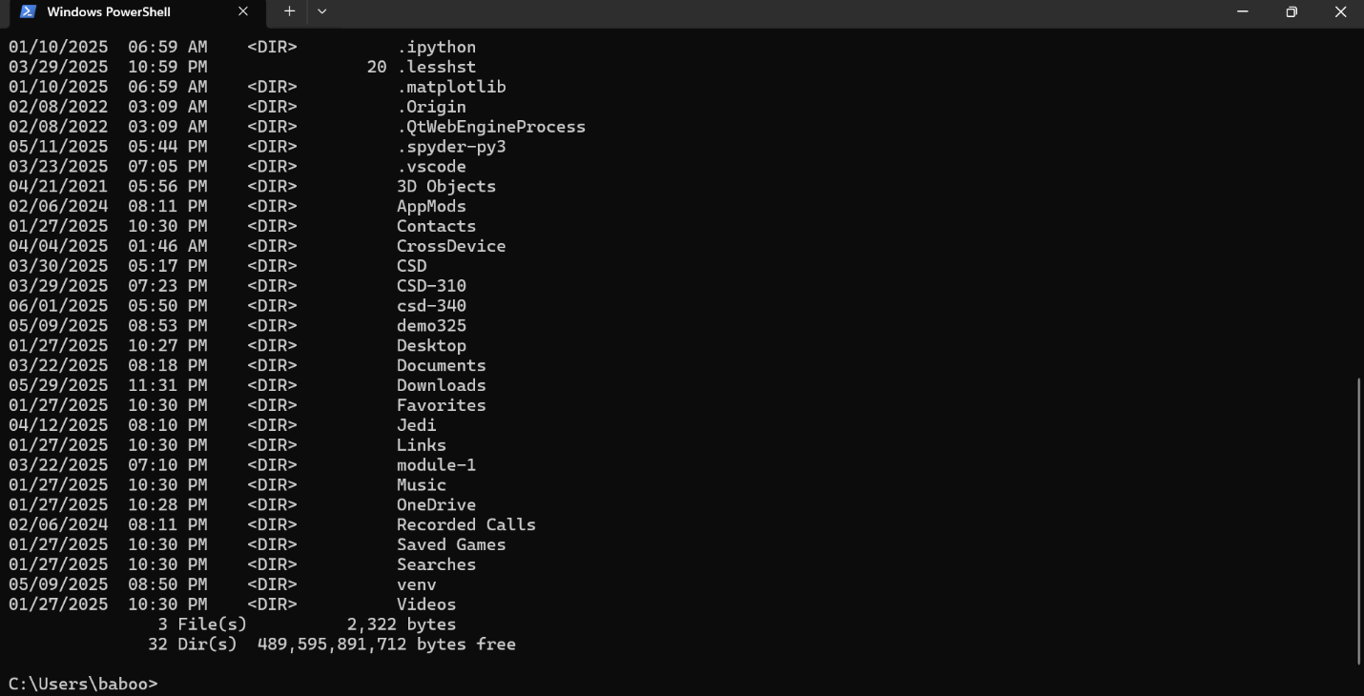
3. Screenshot of my GitHub repository: 